A Visceral Slide Into Darkness

‘Toxic Psalms,’ in the Prototype Festival, Explores Ethical Choices
JAN. 7, 2015
Photo
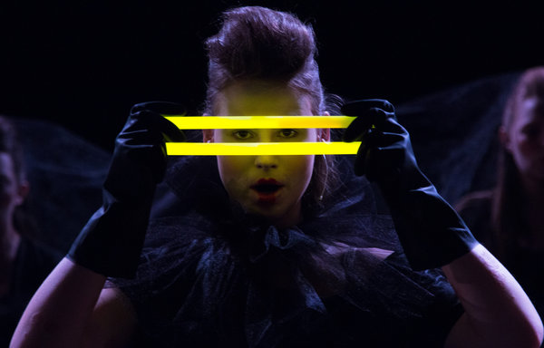
"Toxic Psalms" was partly inspired by studies that revealed how people can be persuaded to do others harm. Above, Ana Sandrin, with glow sticks. Credit Dorian Šilec Petek

The members of the chorus pace restlessly around the stage, periodically halting in ominous formations. Sometimes they sing at one another in a whisper, but using megaphones. The floor is littered with lemons, and the lighting is stark. Some of the performers wear elaborate, antiquated black gowns, as if mourners at a Victorian funeral. Some don combat boots.
“Toxic Psalms,” the latest production by the Slovenian vocal ensembleCarmina Slovenica, is hardly what you’d expect from a choir concert. Opening Thursday at St. Ann’s Warehouse in Brooklyn, it is part of the first night of Prototype: Opera/Theater/Now, an annual festival of contemporary music and performance. The work could stand for Prototype as a whole: vibrantly theatrical, genre-blurring, unusual in its techniques, eclectic in its musical style and politically charged — if also, in this case, politically ambiguous.
“I’m not an agitator for something specific needing to be done,” Karmina Silec, artistic director of Carmina Slovenica and director of “Toxic Psalms,” said in an interview at Here Arts Center, a co-producer of Prototype, in SoHo. “I just like to give a meditation on certain things for the audience, so they can decide what they feel, what they see, how they respond.”
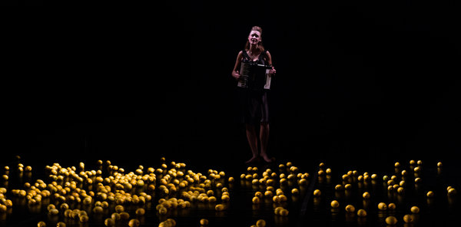
Lemons, representing symbols of purity, litter the stage in "Toxic Psalms," a meditation on a collective's ethical choices. Credit Dorian Šilec Petek

The meditation here is on a collective’s ethical choices and the ways a group can be enlisted as a force for evil. And as a force for resistance: “Toxic Psalms” pointedly includes, among a mixture of contemporary and early music, “Rejoice, O Virgin” from Rachmaninoff’s Vespers, on which the Russian punk group Pussy Riot based the song that got members imprisoned for hooliganism in 2012.
In developing the piece, Ms. Silec, 47, was inspired by “Eichmann in Jerusalem,” Hannah Arendt’s classic Holocaust study, as well as by the psychologist Stanley Milgram’s obedience studies of the early 1960s, which revealed the ease with which people can be persuaded to do others harm.
She made the process of creating “Toxic Psalms” — which had its premiere, in a substantially different version, last year in Berlin and runs for five performances through Sunday — a kind of experiment in itself. While she usually conducts the group’s performances, this time she barely even inserted herself in rehearsals, letting the members largely find their own way over six months of preparation.
“There was no leader to take responsibility,” she recalled. “I think it was very refreshing for all of us.” The piece became, as she described it, the “ultimate collective experience.”
The set, designed by Ms. Silec, is basic. As she said, “We don’t need many things, because the body onstage is already a prop, is already scenography.” “Toxic Psalms” is full of images of coercion and oppression, enacted with sometimes frightening gusto.
Ms. Silec attributed her 31 performers’ readiness for this unusual experience to their youth: The ensemble members are all still students, and the eldest is 23. “They’re open for everything,” she said. “Everything is new, and it’s fresh and it’s honest. The willingness to shape things is very different than in older professionals.”
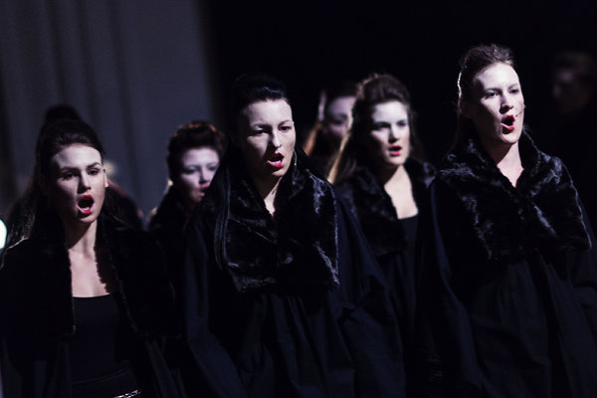
Some of the 31 performers in Karmina Silec's latest production. CreditRudi Uran

Though a departure for the group in terms of how it was rehearsed, “Toxic Psalms” is also a continuation, the latest in a series of pieces Ms. Silec and Carmina Slovenica have created over the past decade or so using a technique she calls “choregie,” a portmanteau of the German words for chorus and theater direction. Derived from her understanding of the role the chorus played in ancient Greek drama as a stand-in for the audience, “choregie” projects combine wide-ranging music. “Toxic Psalms” includes, among other selections, a Syrian Orthodox hymn, Sarah Hopkins’s “Past Life Melodies,” and works by the Slovenian composer Lojze Lebic and the American Jacob Cooper. The variety of styles are brought together with a unifying approach to design, direction and choreography.
“Her whole process is about the music coming into the body,” Kim Whitener, producing director of Here Arts Center, said of Ms. Silec.
Without really intending to, the Prototype curators have ended up with a festival (running through Jan. 17) in which choruses play an unusually significant role. “Winter’s Child,” by Ellen Reid and Amanda Jane Shank, includes a nine-person female vocal ensemble drawn from the ranks of the excellent choir of Trinity Wall Street. The Brooklyn Youth Chorus sings in “Aging Magician,” created by Paola Prestini, Rinde Eckert and Julian Crouch; and Todd Almond’s “Kansas City Choir Boy,” which stars Courtney Love, also involves a chorus of sirens.
Choruses, it seems, are hot these days. So are the extended vocal techniques learned from experimental precursors like Meredith Monk as well as borrowed from throat singers and screaming shepherds. Caroline Shaw’s “Partita for Eight Voices,” winner of the 2013 Pulitzer Prize for Music, is a sunnier version of many of the idiosyncratic, keening, humming sounds featured in “Toxic Psalms.”
But little in recent performance, particularly in America, has prepared audiences for Ms. Silec’s union of those sounds and brooding theatricality. “It’s a very visceral experience,” said Beth Morrison, co-producer of Prototype. “When we started to really get to know what she was doing, it became clear that no one is doing this in the way that she’s doing it.”
While Ms. Silec is friendly and voluble in person, she clearly seems to have little patience for sweetness. Asked if she’d be sightseeing while in New York, she said she planned to visit some notable cemeteries. As a line in her program notes puts it, “Death speaks and murderous plague intones in the background of the whole concert arch.”
But “Toxic Psalms” contains glimmers of light amid the darkness. Those omnipresent lemons, for one thing, which Ms. Silec has included as symbols of purity and the cleansing away of bad energies. Merely giving audiences the opportunity to focus steadily on a 90-minute performance, in a culture defined by attention deficits, is for her a positive act.
“We are very fast in everything today,” she said. “We are not patient as listeners or performers. Just as there is slow food, I like to have the slow music experience.”

